February 16, 2024

Re: State of Montana v. Craig Allen McCrea
Montana Twentieth Judicial District Court
Lake County - DC-22-126

To Whom It May Concern;

On July 31, 2021, the Boulder 2700 Fire erupted just north of Finley Point in Polson, Montana. The fire destroyed thousands of acres of forest, damaged, or destroyed dozens of buildings, and forced the emergency evacuation of hundreds of families. On February 2, 2024, the State of Montana proceeded to trial in the above-referenced case and a Lake County jury ultimately found Craig Allen McCrea guilty of arson related to two fires, including the Boulder 2700 Fire. Sentencing has been set to begin at 10:00 a.m. on May 3, 2024, at the Lake County Courthouse.

You are being contacted because you were evacuated during the fire and are therefore a victim in the above-referenced case. As such, you have the right to submit a victim impact statement which the presiding judge will review prior to sentencing. You also have the right to request restitution for any expenses that you incurred because of the evacuation. If you wish to submit a victim impact form or a restitution request, please call Adult Probation & Parole Officer Katie Campbell at 406-872-6254 or contact her by email at kampbell2@mt.gov as soon as possible. There will also be an informational meeting for victims at the Lake County Courthouse on Friday, March 15, 2024, at 12:00 p.m., and again on Friday, March 29, 2024, at 12:00 p.m. if you have additional questions.

Thank you for your assistance in this case.
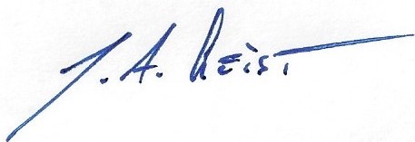

Thorin A. Geist
Assistant Attorney General

