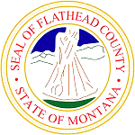
Flathead County
(406) 758-5503
800 S Main St, Kalispell, MT 59901

News Release

Thursday, February 22, 2024 - Kalispell

Electric Street and River Street will close for the annual Bigfork Brewfest, Saturday, March 2, 10:00 a.m. until 7:00 p.m. Parking will be restricted on both sides of River Street and Osborn Avenue. Attendees are encouraged to park in the Grand Drive parking lot.

As a reminder, the Bridge Street Bridge is closed to pedestrian access and vehicle traffic.

Below is the traffic plan for the Bigfork Brewfest.
