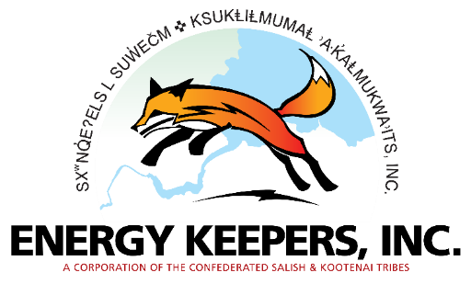
Robert McDonald
Communications Director
Energy Keepers, Inc
robert.mcdonald@energykeepersinc.com
406-249-1818

FOR IMMEDIATE RELEASE:
April 3, 2024

Corps Approves Lake Level Variation

Polson, Montana -- The U.S. Army Corps of Engineers (USACE) approved a request from Energy Keepers, Inc (EKI) to deviate from the Flood Risk Management plan by allowing for a higher spring lake level than usual. Typically, each spring, the water level is taken down to 2883’ levels.
The requested change, approved March 25, would raise the flood risk management elevation on April 15 from 2883’ to 2885’ range. The established Flood Risk Management is dictated by a 1965 Memorandum of Understanding with the USACE. The deviation increases the probability of lake refill in June, however, the flood risk is minimal.
“It is expected that this relaxation would have minimal risk based on modeling an analysis of current conditions,” states the letter from the USACE.
The summer flows in 2023 remain among the driest seen in the history of the lake, a pattern that forecasters are seeing continuing into 2024. Flathead lake began refilling operations earlier this year to respond to precipitation and hydrological trends.
“By taking these actions early in the season we increase the likelihood Flathead Lake will reach its maximum elevation in what forecasters are predicting as another dry year,” said Brian Lipscomb, EKI CEO. “Should we experience unforeseen precipitation then we can make further adjustments. By May, we are prepared to make further changes to standard operations depending on weather conditions.”
EKI staff conduct frequent analysis and projections of hydrological conditions to ensure top management practices and actions. Flathead Lake will likely be in the 2888’-2891’ range at the end of May.
About Energy Keepers, Inc

Energy Keepers, Inc (EKI) is a federally chartered corporation created and wholly owned by the Confederated Salish and Kootenai Tribes (CSKT) of the Flathead Reservation, pursuant to Section 17 of the Indian Reorganization Act of 1934. As well as developing economically, CSKT is nationally recognized as leaders amongst Tribal nations for exercising their sovereign powers to preserve and protect cultural, wildlife, and natural resources of their traditional homeland now and for future generations. CSKT and EKI are the co-licensees of FERC Project No. 5, the Seli’š Ksanka Qlispe’ Project located on Tribal Land six miles below the natural outlet of Flathead Lake on the Lower Flathead River.

-30-

