FALL DEBRIS BURNING TO OPEN SEPTEMBER 15

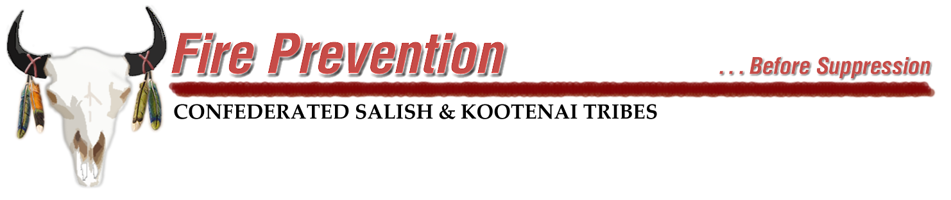
September 10, 2026- Open debris burning for the Fall burning season will open early this year. Fall debris burning usually opens on October 1, but with the precipitation that has occurred in late August and into September has dropped fire danger to Moderate and trending to Low. The Division of Fire officials feel it is safe to open debris burning early on the Flathead Indian Reservation. To burn from September 15 to November 30 you do not need a burn permit.

If a fire does get out of control call 911 immediately.

Remember you are responsible for any and all suppression, property costs if your fire escapes your control.
If you have any questions about debris burning call the Division of Fire at 676-2550.

Follow us on Facebook. CSKT Division of Fire.

